**Containerizing and Deploying the Explore California Sample Web App**

1. Sample web app:

  - Fork the [Explore California repository](<https://github.com/mickeyjohn/explore_california)> and clone it local

Git fork = used fork button to fork

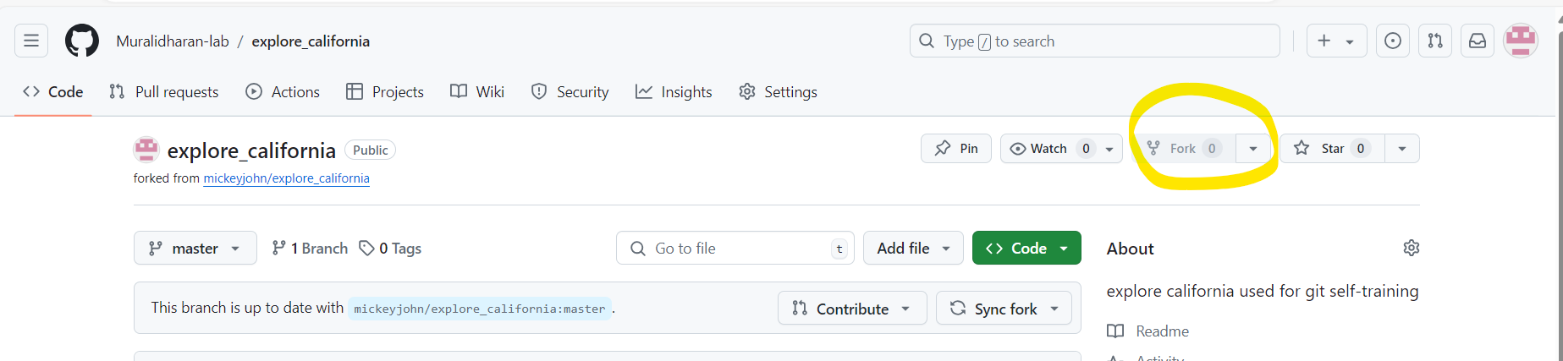

Copy the URL then run git clone <https://github.com/Muralidharan-lab/explore_california.git> in git bash to clone the repo

2. Kubernetes Runtime Setup: Rancher Desktop

Link to Install Ranger desktop: [Rancher Desktop by SUSE](https://rancherdesktop.io/)

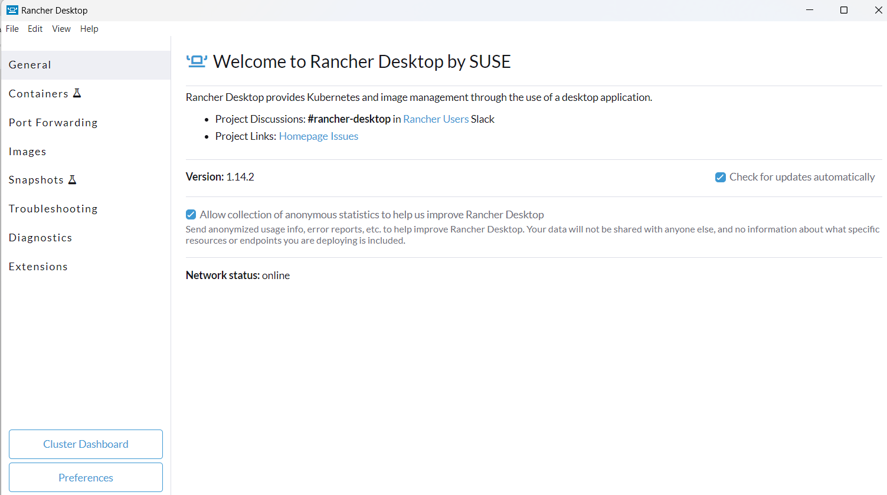

install Linux on Windows with WSL: [Install WSL | Microsoft Learn](https://learn.microsoft.com/en-us/windows/wsl/install)

Run in powershell : wsl --install

3. Containerization:

  - Write a Dockerfile for the web app and build the image.

  - Test the containerized app to ensure it runs correctly.

In linux : install docker,kubectl,git if its not there

snap install docker

snap install kubectl

snap install git-ubuntu = for clone https://github.com/mickeyjohn/explore_california

Docker login : for pull and push image

Docker file :

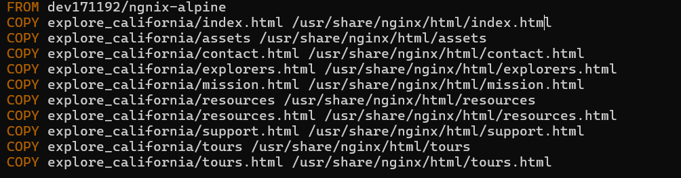

Cmd to build :

* Docker build -t test .

Cmds Tag, push and Run to Docker Hub:

* docker tag test muralidharan1993/murali_demo
* docker push muralidharan1993/murali_demo
* Docker run -d muralidharan1993/murali_demo

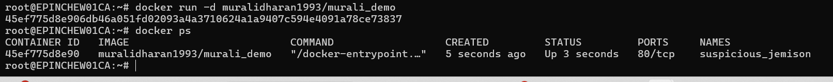

Working status check:

* Docker inspect <CONTAINERID> = run this cmd to get the ip
* curl -kiv 172.17.0.2:80 = to check the o/p

4. Kubernetes Deployment:

Create files for deployment and service.

Deployment.yaml file:

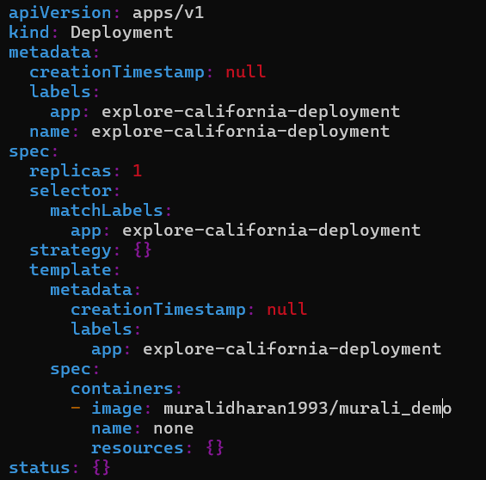

Service.yaml file:

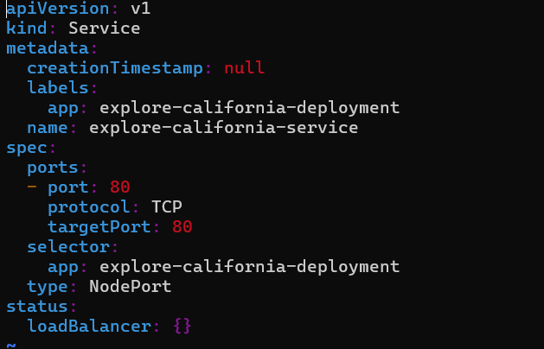

  - Deploy the app to your Kubernetes runtime and ensure it's operational.

Cmds to apply both: kubectl apply -f deployment.yaml && kubectl apply -f service.yaml

Check the pod status: kubectl get pods



Check the service : kubectl get svc



Login to pod: kubectl exec -it explore-california-deployment-6c8f7f6bfc-chqff – sh

Working inside the pod:

5. Exposing the App:

Configured NodePort service to exposing the App:



In Browser: <http://localhost:30382>

